|  |  |  |
| --- | --- | --- |
| WOODROW WILSON ELEMENTARY SCHOOL  BINGHAMTON - SCHOOL |  |  |
|  |  |  |
| School Detail :- Our Wilson School Staff is dedicated to providing a campus that promotes and reinforces a clean, safe and orderly learning environment to allow every student the opportunity to achieve to his or her fullest potential.  Our Wilson School Staff is dedicated to providing a campus that promotes and reinforces a clean, safe and orderly learning environment to allow every student the opportunity to achieve to his or her fullest potential.  Our Wilson School Staff is dedicated to providing a campus that promotes and reinforces a clean, safe and orderly learning environment to allow every student the opportunity to achieve to his or her fullest potential. Our Wilson School Staff is dedicated to providing a campus that promotes and reinforces a clean, safe and orderly learning environment to allow every student the opportunity to achieve to his or her fullest potential. Our Wilson School Staff is dedicated to providing a campus that promotes and reinforces a clean, safe and orderly learning environment to allow every student the opportunity to achieve to his or her fullest potential. |  |  |
|  |

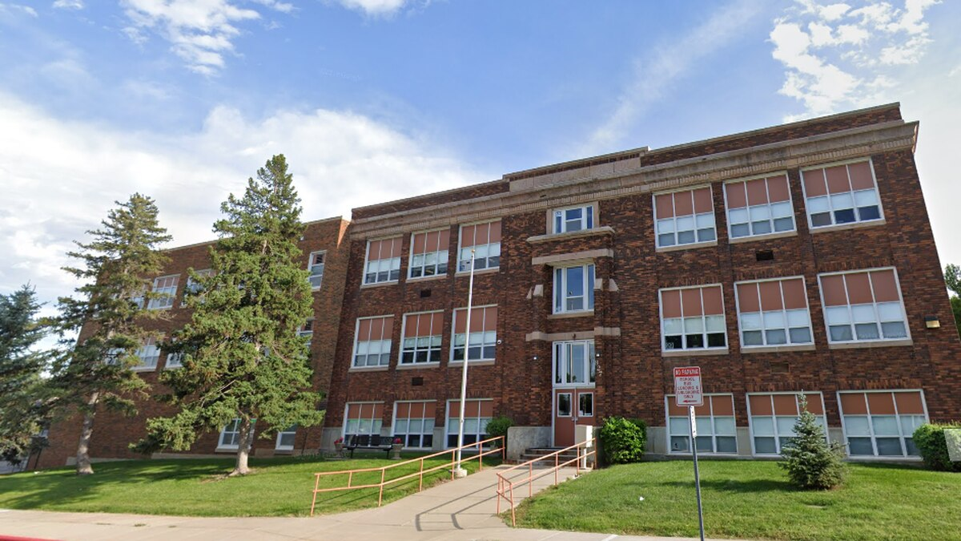

MINIMUM CAPACITY :-

The Minumum intake capacity

of students is between 3000-3500

children

LIBRARY :-

The Libarary is Available.

CANTEEN:-

The Canteen Facility is Available.

BOARDING :-

No availablility of boarding.

SPORTS :-

There are different categories

sports available.

Girls Volleyball

Boys Volleyball

Football